GPU Computing: Assignment 3

*GPU used: GTX 1060 Max-Q, CUDA compute capability: 6.1 Pascal*

**Task (1)**

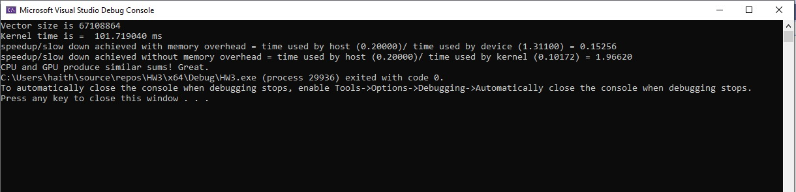

**Task (2)**

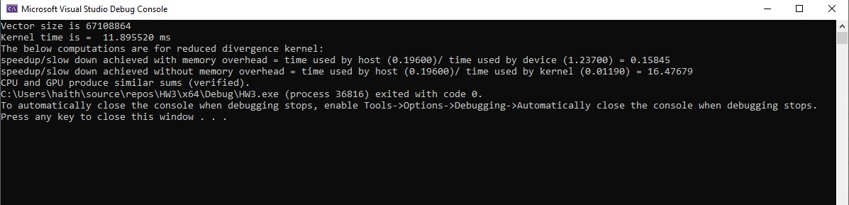

**For both tasks, we used a vector size of 67,108,864. It was chosen purposely large to highlight the kernel advantage for processing large data. In fact, for smaller vectors the CPU actually outperforms the GPU.

The above figures show that reduced divergence significantly improves the kernel performance and increases the speedup obtained.

**Task (3)**

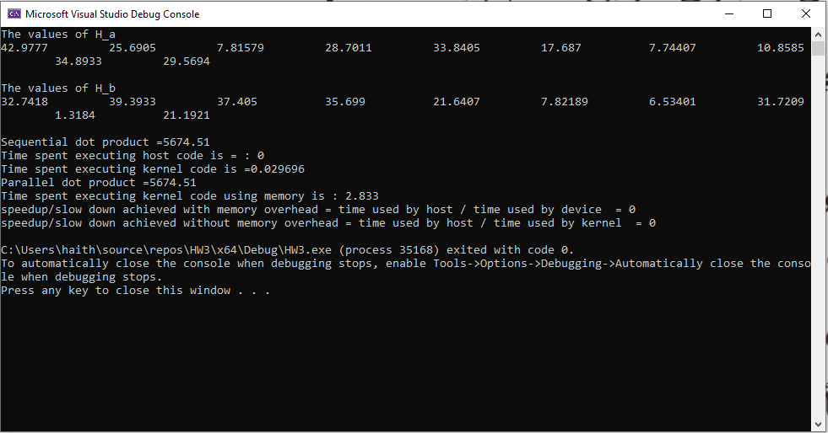

**Task(4)**

To verify the output of Q(4), an online tool was used to compare its results with results computed by code and they both matched as illustrated below.

**Online Tool**

**Equations used**

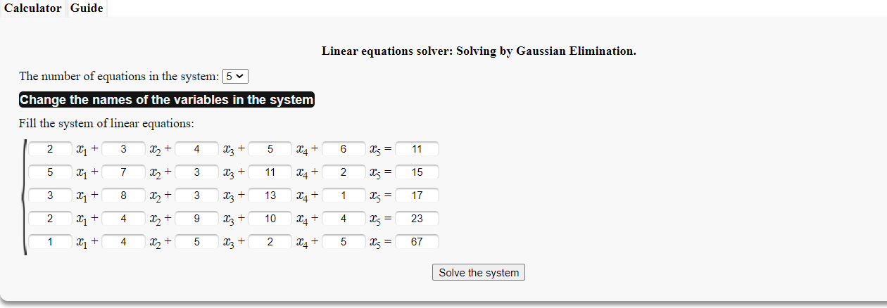

**Online Tool Results**

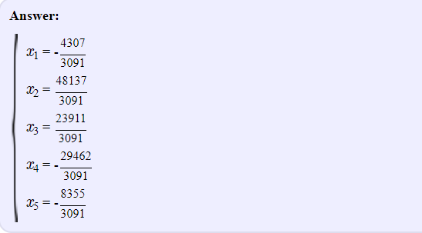

**Code Results**

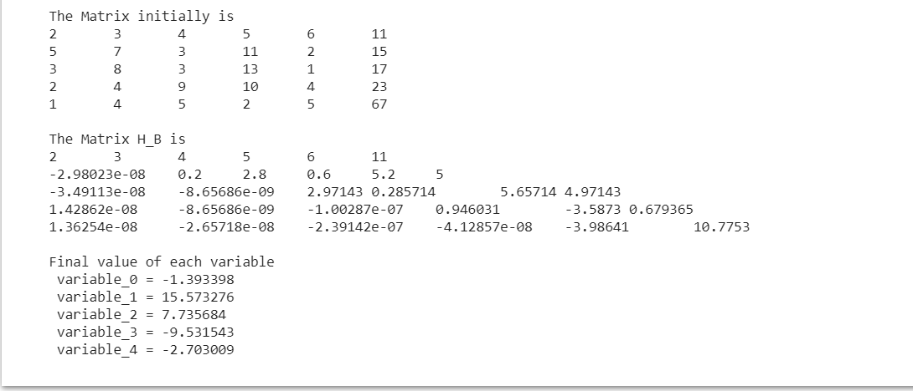

**Class Example**

